TRIBHUVAN UNIVERSITY
INSTITUTE OF ENGINEERING

Purwanchal Campus
Dharan, Nepal
Department of Electronics & Computer Engineering



A PROPOSAL ON
YOUTUBE SONG SCALE FINDER USING KRUMHANSL-SCHMUKLER KEY FINDING ALGORITHM

Submitted in partial fulfillment of the requirements for the degree

BACHELOR OF COMPUTER ENGINEERING

Submitted by
Youbraj Kafle PUR075BCT094
Siddhant Bhagat PUR075BCT079
Sabi Kurmi PUR075BCT068
Rishab Acharya PUR075BCT066

Under the Supervision of
Er. Manoj Kumar Guragain

Purwanchal Campus
Dharan, Nepal
May 24, 2022

Abstract

No efficient environment for analyzing scale of YouTube songs is present in the present context. Scales are one of the most important building blocks of music. Along with chords, intervals and progressions, scales are most essential music theory concept if we want to write songs or produce tracks. The proposed system acts as a song/music scale finder for YouTube songs/videos as chrome browser extension for desktop systems. A lot of time is spent while finding scale of song that includes either manually finding song scale from musical instruments or using existing software that wastes so much time when it comes to the analyzing scale of YouTube songs as no direct method is present. There are so many websites/software that finds scale/key of song but we will need to download video/song from the YouTube that we desired for and it takes lots of time. To avoid so much time wasting, this system is proposed. Song scale can be found by using Krumhansl-Schmuckler key-finding algorithm which is based on Artificial Neural Network(ANN). Front-end tools include HTML, CSS, JavaScript with back-end solution like Django. On the completion of this project, it is expected to facilitate an effective and efficient platform for finding scale of YouTube songs.

Keywords:YouTube song, chrome extesnsion, scale, Krumhansl-Schmukler key finding algorithm, Artificial Neural Network, ANN

1. Introduction

YouTube song scale finder is a chrome browser extension for desktop system that finds scale of YouTube song that is open in current tab of the Chrome. This extension provides features like selecting particular section of YouTube video/song to find scale for that section.

1.1 Background

A scale is a sequence of small intervals - in Western music, those intervals are usually tones (whole steps) and semi-tones (half steps). To identify a specific scale, we need to know its unique sequence of intervals. Scales based on the diatonic scale will always consist of 5 tones and 2 semi-tones. Therefore, manually recognizing these scales can be simplified by identifying the position of their two semitones.

Scales are one of the most important building blocks of music. Along with chords, intervals and progressions, scales are most essential music theory concept if we want to write songs or produce tracks. Scales in music are a collection of notes played one after another following a set pattern of intervals. The pattern defines the quality of the scale and repeats with the same set of pitches at each octave. Scales are most commonly used as the melodic form of the set of notes in keys.

1.2 Objective and Application

It’s objective is to provide better and efficient way for identifying scale of song. There are no such platforms from which we don’t need to download whole video/song from YouTube to know it’s music scale. This situation lead to realize such interactive platform. This can be used by anyone who have interests in music or those who are involved in music like music artists.

2. Literature Review

Although, many methods for retrieving music scale have been proposed through encoded symbols(like MID) format, they are not applicable in the case of acoustically encoded music data. There are three existing techniques present for indexing and retrieval of acoustic music: music transcription, temporal structure discovery, and genre classification.
For music transcription, only few techniques were proposed which characterizes musical regularity (up to measure level) in music signal. However, this only works for simple situations like a particular instrument.
For temporal structure (e.g. chorus) discovery, temporal structure of songs are detected by exploring the self similarity in the feature sequence.
For genre classification, various supervised classification techniques are proposed which aims to classify the audio files in certain categories of sound to which they belong.
In this project, we have proposed a generic approach for detecting the scale root and the key from the audio signal. This technique works for any style of music (pop or classical) that is based on diatonic scale or keys. In this approach we use Krumhansl-Schmukler key finding algorithm that compares a musical input to templates associated with different musical keys. These templates are derived from the probe-tone method. The template that provides the best match to the musical input is used to assign a key to the input.

3. Methodology

3.1 System Data Flow Diagram:

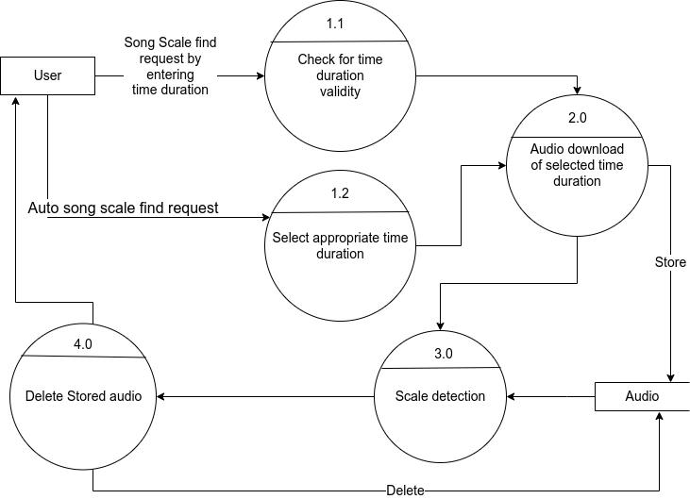

3.2 Tools

This project will be implemented using HTML, CSS, and JavaScript for front-end,
Django for back-end.

3.2.1 External Interface Requirement
User Interfaces
Front-end software: Chrome Browser
Back-end software: Python3

Hardware Interfaces
Any of the modern desktop operating system (Windows/Linux/Mac)
Latest, stable releases of chrome browser.(Any other browser except chrome is not supported.)

4. Expected Outcome

We have expected to develop a chrome extension of YouTube song scale finder. The final product is expected to predict music scale of any song. For example: A# major. We are expecting the output model to be as accurate as possible and the performance of our model to be as quick as possible. The interface will be simple and attractive so that any user can easily use it.
The user will be provided with an interface where he/she can either input particular time duration or select automatic scale finding option for any song and the processing will be done in back-end. Thus finally, the output will be displayed showing the correct music scale of song.

5. Project Schedule

The following chart presents the tentative schedule for the project.
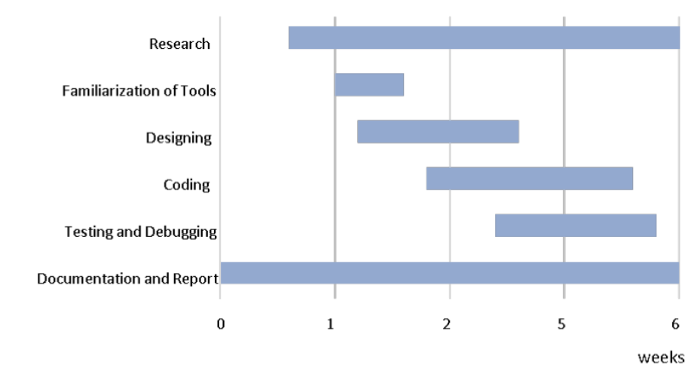

6. Conclusion

This project is targeted to analyze scale of YouTube songs as chrome browser extension. Although, there are various methods of finding scale of song but we need to download the song/video from YouTube whose scale need to be identified and that causes so much time consuming. As it is not identifiable by human brain, either musical instruments or scale detecting devices/software can be used for it. Implementing the algorithms and tools selected as above in a proper way is a critical aspect of this project. Output is supposed to be presented as correct scale of song that is being opened in current tab of chrome browser. Hope the coordination and constant teamwork along with learning will lead the project to success and also the project will be an efficient way of learning and achieving different practical knowledge regarding Artificial Neural Networks(ANN).

7. Bibliography

References

Dawson, Michael H. R. “Connectionist Representations of Tonal Music”, Athabasca University Press, DawsonMarch 2018.
Hart, Robert. “Key-Finding Algorithm.”Robert Hart’s Homepage, http://rnhart.net/articles/key-finding/. Accessed 16 May 2022.
Yongwei, Zhu, et al.”Music Key Detection for Musical Audio” 11th International Multimedia Modelling Conference. Feb 2005, doi:10.1109/mmmc.2005.56.

Glossary

ANN Artificial Neural Network
MIDI Musical Instrument Digital Interface
HTML Hypertext Markup Language
CSS Cascading Style sheets
Chrome Google Chrome

